**Game Design: 3rd person Parkour Action Game (Untitled)**

***Game Mechanics:***

**Core Game Play:**

A 3rd person parkour action game. With bright, colourful, cell-shaded and cartoon-ish graphics. Taking place in a smaller, more detailed and hopefully interesting open world, with combat that's simple, easy to pick up with a good amount of challenge, but not so simplistic that it becomes a mindless button masher.

* 3rd Person
* Parkour
* Action
* Open World

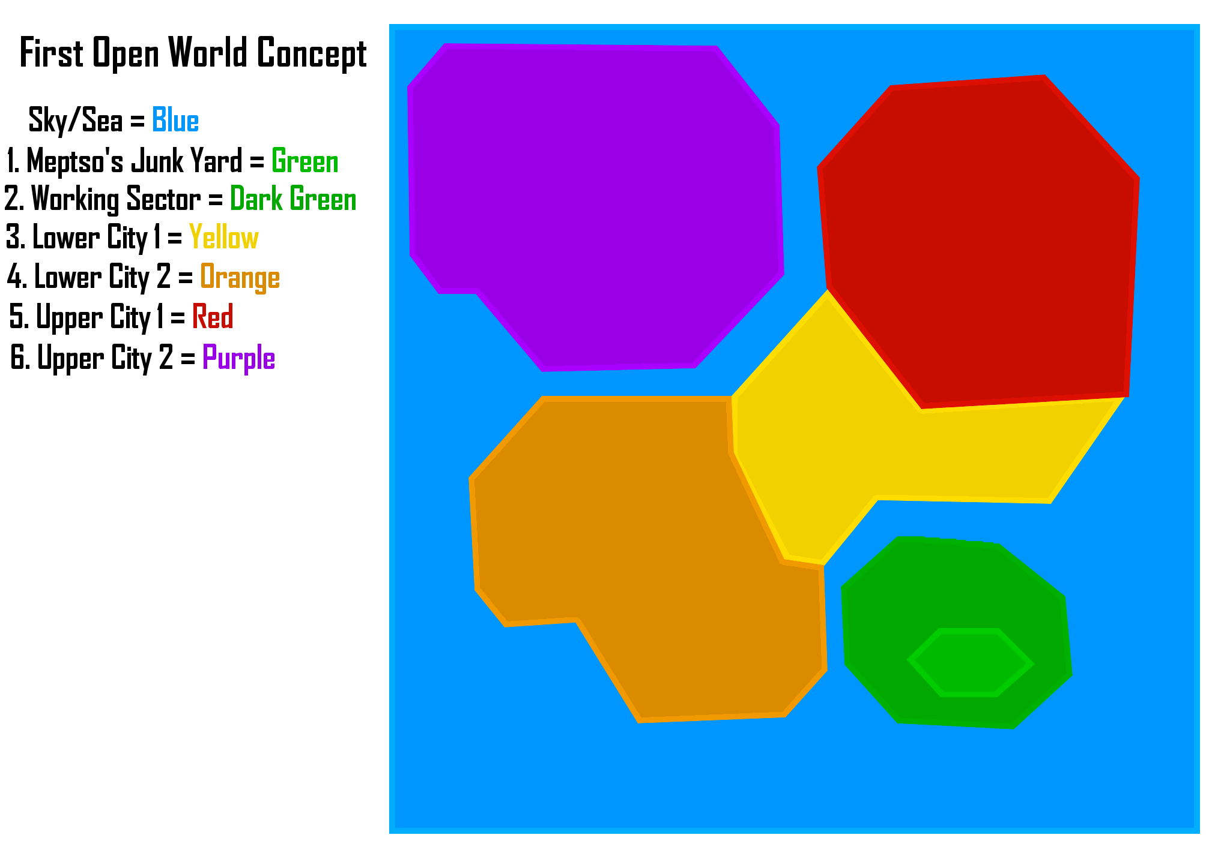

* Cartoon/Cell Shaded Graphics

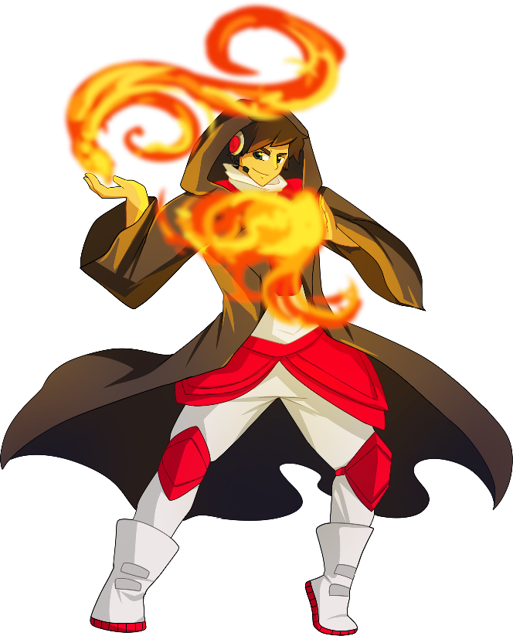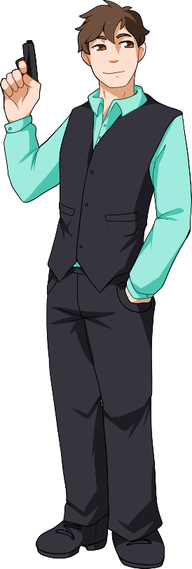

**Game Flow:**

* The World: As the player plays the game and progresses further and further into the game and the story. The map changes with different seasons that will change the look and feeling of the world and create new obstacles for the player to adapt to and overcome; i.e. frozen lakes and frosty surfaces in winter, etc. New areas once left inaccessible, become open to the player as they acquire new abilities and their understanding of how the parkour system works and their use of it becomes more organic.
* Move: player can move forward, back, left, right.
* Jump: player can jump over obstacles, jump to reach higher places, jump over enemies in combat.
* Parkour: player can parkour around the world, i.e. wall run along walls, wall jump off walls and chain wall jumps together to reach higher places, rail grind along rails and other surfaces that can be ground upon, i.e. rails, train tracks, power lines. Just to name a few.
* Attack: the combat revolves around using a variety of attacks and utilising momentum to deal extra damage. For example, the player can only use a slide attack if they have enough momentum and a tackle/clothesline attack deals more damage equal to the momentum behind it.
* Kill Enemies: player can attack enemies until their HP reaches zero, where they then die.
* Attack Type Resistant Enemies: some enemies are resistant to certain kinds of attacks and techniques that the player may have adapted during play, i.e. one enemy may be too agile to hit normally, so the player will have to attack the enemy when they charge in order to hit them. Another enemy maybe a tank or other form of vehicle and the player has to approach it from a blind spot or dodge attacks until a window of opportunity to strike opens and then kill it.
* Solve Puzzles: the puzzles in the game revolve around parkour and figuring out how to reach/achieve an objective using parkour; study their surroundings, figure out a path, use path to see if it works, repeat until successful.

**Characters:**

* Player "Android" - this is the character which is controlled by the player.
* Health Points: medium, grows as they gains experience.
* Attack Power: medium, grows as they gain experience and learns new attacks.
* Defence: medium, grows as they gain experience.
* Speed: medium, grows as they gain experience.
* Specialized attacks - learnt throughout the game.
* Extra Notes –
* Enemy "Guardroid" - low level enemy, no resistances or weaknesses to any particular kind of attack, little experience gained when defeated.
* Health Points: low.
* Attack Power: low.
* Defence: low.
* Speed: medium.
* Specialized attacks - none.
* Attack Strategy - bum rush player and attack with "Basic Attack", easily defeated in 1v1, but become a hassle for the player when there's enough numbers for them to dog pile the player.
* Extra Notes - number of Grunts in enemy encounters slowly increases as the difficulty increases as do their stats to match the player and keep the challenge.
* Enemy "Driftster"  - low to mid-level enemy, no resistances or weaknesses to any particular kind of attack, less numbers and a little rarer than the Guardroids, average experience gained when defeated.
* Health Points: low.
* Attack Power: low to medium.
* Defence: low.
* Speed: high.
* Items: anti-grav boots.
* Specialized attacks - Charge: charges at player at high speed
* Attack Strategy - circles around the player at high speed, avoiding their attacks, until they attack with their specialized attack "Charge".
* Extra Notes - number of Speedsters in enemy encounters slowly grows as difficulty increases as does their stats, has rocket/anti-gravity boots.
* Enemy "Tanker" - difficult to defeat, resistant to standard attacks, must be defeated by working your way to its weak spot and pelting it, large experience gained when defeated.
* Health Points: high.
* Attack Power: high.
* Defence: high.
* Speed: low.
* Specialized attacks - Slam Dunk: smashes fists the ground damaging anything in the attack's area of effect.
* Attack Strategy - Use Slam Dunk attack when player is in range.
* NPC "Citizen" - is there to bring the city to life with people.
* Health Points: low.
* Attack Power: none.
* Defence: low.
* Speed: medium.
* Specialized attacks – none
* Attack Strategy - doesn't attack.
* Extra Notes - reacts to events going on around them, i.e. player running into them, player fighting enemies, etc.

**Game Play Elements:**

The basics of the Parkour system are taught to the player via exploration and or discovery of the parkour system, i.e. a controlled environment where the player has a goal to reach and must figure out how to do so by working out what does and doesn't work themselves. If they get stuck, they can look up the tutorials in the controls menu. This the player can learn how the game works, without holding their hand all the way through and allows those that get stuck to look at tutorials:

* The player can "jump."
* The player can "roll".
* The player can "sprint".
* The player can "wall run" along walls/flat surfaces until their momentum runs out.
* The player can "wall jump" off walls/flat surfaces and chain wall jumps together.

The basics of combat and the basic attacks are introduced in a combat encounter on the first mission and taught via pop ups on the players HUD demonstrating the two attacks listed below.

* The player can use a "Basic" Attack (Fisticups).
* The player can use a "Heavy" Attack (Knee to the Face).

I haven't been able to plan past the opening mission yet, so I'll list other game play elements here:

* The player can "rail grind" along rails, train tracks and power lines.
* The player can interact with Mepsto at the junk yard and "upgrade vendors" throughout the world where the player uses their exp to buy upgrades and abilities.
* The player can interact with the mission markers that are across the map. The player can interact with these to access story missions, side missions and challenge missions.
* The player can interact with "signal towers" around the world that opens an in-game multiplayer menu, the same menu can be opened from the main menu as well. The signal towers act as an in game way to host a multiplayer game or connect to other multiplayer games without breaking the flow of the game to much.

**Game Physics and Statistics:**

Movement:

* characters gain momentum as they move and will "gradually" slow to a stop if momentum is not being applied to them/input movement is false, momentum is reduced and is harder to gather when they move up an incline, gains momentum faster when moving down an incline or falling.
* characters with a lower speed stat have a lower max speed and gather momentum slower, while characters with a higher speed stat have a higher max speed and gather momentum quicker (lighter characters gather momentum faster and will)
* The "anti-grav boots" lower the variable of friction to the lowest point so that they gather momentum faster, but take longer to slow to a stop due to their lack of friction.

Collision:

* Characters will stop dead and even rebound when they run into something heavier than they are, or something that has more momentum then they do.
* A characters momentum will cancel out if they collide with an object with no give, i.e. walls, heavier enemies.
* Player will trip over smaller enemies and NPCs if they run into them within a certain amount of speed.

Combat:

* Momentum = damage. The higher a characters momentum, the more damage they do.

**Artificial Intelligence:**

Enemies:

General:

* Will spawn and walk along predetermined patrol paths throughout the world.
* Combat state will be triggered, if the player/s enter their visibility range.
* If an enemy in its combat state enters the visibility range of another enemy whose combat state hasn't been triggered, the un-triggered enemy's combat state will be triggered.
* (if the player leaves their visibility range, they will report the player's last known location to the "network" giving)

Guardroids:

* If a grunt in its combat state doesn't see any other enemies in their visibility range, they will call for re-enforcements.
* A grunt in its combat state will bum rush the player and attack them, unless they are alone and a certain distance away, if that’s the case they will call for re-enforcements.

Driftsters:

* A Driftster in it's in its combat state will circle around the player staying out of their range, avoiding other entities that they can collide with, building up enough momentum before charging the player.

Tanker:

* A tanker in its combat state will make very little if no movement at all, making sure that it is constantly facing the player.

**Multiplayer:**

* The multiplayer is co-op based with player hosted sessions of 2 - 8 players, where the players are given free roam of the entire city that is available to them.
* The multiplayer can be activated/accessed from the signal towers throughout the city and the main menu where players can access the multiplayer features.
* The only thing that really changes from multiplayer and solo-player, is that the story and side missions and solo player challenges are replaced with multiplayer missions and challenges, i.e. mega boss fights, races, challenges, etc.

**User Interface:**

**Flowchart:**

Refer to: 3rd Person Parkour Action Game Flow Chart

**Functional Requirements:**

* Launcher Menu: lists the launch game and options menu.
* Launch Game: launches the game.
* Options Menu: opens options menu where video options, audio options, game settings and control settings can be accessed.
* Video Options Menu: opens the video options menu where video options, i.e. display mode, resolution, graphics settings, render distance, etc, can be edited and managed to suit the player's rig and maximize performance across different builds.
* Audio Options Menu: opens the audio options menu where audio options, i.e. music volume, SFX, vocal volume, etc, can be changed and managed.
* Game Settings Menu: opens game settings menu where the game's settings can be changed and managed.
* Control Settings Menu: opens the control settings menu where the controls, i.e. controller or mouse and keyboard, mouse inversion, key-bindings, etc, can be edited to suit the player's preference.
* Main Menu: lists the play/save/d games, multiplayer and options menus.
* Play: opens the menu for selecting start new game and load saved game.
* Start New Game: Starts a new game.
* Load Saved Game: opens the select saved game menu.
* Select Saved Game: opens a list of saved games to play and start from the last point where they saved.
* Multiplayer Menu: lists the host wireless, LAN and join multiplayer game menus.
* Host Wireless Multiplayer Game Menu: Opens a menu of settings, options and a start button for hosting a wireless multiplayer game.
* Join Multiplayer Game Menu: lists active multiplayer games.
* Host LAN Multiplayer Game Menu: Opens a menu of settings, options and a start button for hosting a LAN multiplayer game.
* Pause Menu: pauses the game and lists resume, options, exit to main menu and quit.  
  Resume: returns to the game.
* Options Menu: opens options menu where video options, audio options, game settings and control settings can be accessed.
* Main Menu: closes the game and returns the player to the main menu.
* Quit: closes the game.

**Mock-ups:**

Didn’t have time to do this in the end sadly.

**GUI Objects:**

* Player Health Bar:
* Speedometer:
* Cross Hair:
* Mini-Map:
* World-Map:
* Party List:
* Mission Markers:
* Signal Towers:
* Enemy Health Bars:
* Lock on Targeteer:
* Combat State Icon:

***Art and Video:***

**Overall Goals:**

* Bright, colourful, cartoon-ish graphics and designs.
* The beginning of the game is the darkest and drabbest of all the world with: Mepsto's Junk Yard, a cold, damp, concrete pit in the working class sector of the city/world, populated with scrap piles of old, derelict machines. The bright lights of the city above the yard illuminate the night sky and the arms of the cranes that hang lifelessly casting ominous shadows upon the yard below.
* The junk yard feels like a cold and lonely place, with a colder and "rusted" palette. There's stark different between the Junk Yard and the surrounding city which is unlocked in the missions after the intro. The city is alive with people, brightly lit by the advertising bill boards and signs that protrude from the buildings, similar to the streets of Hong Kong.

**2D Art & Animation:**

**GUI:**

* Screens: launcher screen, game main screen, pause screen
* Menus: launcher menu, launcher options menu, game main menu, multiplayer menu, options menu, pause window, world map, in-game multiplayer window, in-game options window.
* Menu Buttons: launcher buttons (editable), main menu buttons (editable), in-game buttons (editable).
* Markers/Icons: story mission markers/icons, side mission markers/icons, challenge mission markers/icons, multiplayer mission markers/icons, multiplayer challenge markers/icons,
* HUD: enemy combat state icons, lock on targeteer, cross hair pointer, player health bar, enemy health bar, mini-map, speedometer, multiplayer party list.
* Pointers: Cross Hair Pointer, menu mouse pointer,

**Marketing and Packaging:**

Not yet completed however would include following based on design/art work developed by Dev team:

* web page art;
* demo splash screens;
* you tube/on line game play ads;
* Steam art.

**Terrain:**

* general textures: trees, bushes (Summer, Autumn, Winter, Spring)
* Mepsto's Junk Yard Textures: Mepsto's Caravan, Junk Yard Workshop, Scrap Heaps (1,2,3), Junk Yard Cranes, Scraped Cars, (Other Junk Yard Equipment)
* Lower City textures: Lower City Buildings, Lower City Streets, Lower City street signs, Lower City traffic lights, Lower City advertisement signs and billboards, lower City citizen/s, lower level vehicles,
* Upper City Textures: Upper city Buildings, Upper city Streets, Upper city street signs, Upper city traffic lights, Upper city citizen/s, Upper city vehicles,
* Terrain Objects: Lower City Buildings, Lower City Streets, Lower City street signs, Lower City traffic lights, Lower City advertisement signs and billboards, Upper city Buildings, Upper city Streets, Upper city street signs, Upper city traffic lights
* Backgrounds: summer sky backgrounds, autumn sky backgrounds, winter backgrounds, spring back grounds, night sky, etc.

**Game Play Elements:**

* Models: Player/s, Gaurdroids, Driftsters, Tankers, Citizens, Buildings, Signal Towers.
* Damage States: Player/s, Guardroids, Driftsters, Tankers, Citizens.
* Animations: Player/s, Grunts, Driftsters, Tankers, Citizens, vehicles.
* Lower city models: Lower city Buildings, Lower city Streets, Lower city street signs, Lower city traffic lights, Lower city advertisement signs and billboards, lower city citizen/s, lower city vehicles,
* Upper city models: Upper city Buildings, Upper city Streets, Upper city street signs, Upper city traffic lights, Upper city citizen/s, Upper city vehicles,

**Special Effects:**

* Advertisement sign and billboard glow effect.
* Rain
* Snow fall
* Foot prints in snow.
* Autumn leaves
* Anti-grav boot trails.

***3D Art and Animation:***

**Cinematics:**

* Intro Cinematic:
* "Reboot" Mission Intro Cinematic:
* "Reboot" Mission End Cinematic:
* In-between Mission Cinematic:

**Video:**

**Sound and Music:**

**Overall Goals:**

* Tron themed music tracks. (This is all I have in mind right now.)

**Sound Effects:**

List all the sound FX required in the game and where they will be used. Include the intended filenames, but be sure to consult with the sound programmer and sound technician (or composer) on the file naming convention. This makes it easier for people to find the sound FX and fold them into the game.

Don’t forget about all the areas that sound FX may be used. You don’t want to overlook anything and throw off the schedule. Go through all the game elements and your art lists to see if there should be some sound associated with them. Here are some to consider:

|  |  |
| --- | --- |
| Sound | Where Used |
| Intro Music | At start of game, during loading sequences and as intro to cut scenes |
| Main Menu Music | Music to loop during main menu |
| 'Select' Sound | Sound to say that a button has been clicked. |
| In Game Music | Dependant on scene and actions involved - gentle for just moving around, more urgent as combat commences.  Mood music dependent on scene |
|  |  |

**Story:**

Write the synopsis of the story told by the game. Include the back-story and detailed character descriptions if it helps. Indicate the game text and dialogue requirements so they can be added to the schedule. Some game designs focus so much on this, that they overlook everything else that should be in the spec. telling a story is not the focus of most games. Of course, if you are doing an adventure game, it is extremely important. Expand and organize this section as is necessary to tell the story.

I really don't have any more than an idea the story yet, I'm just brain storming ideas and seeing what I come up with at this point.

**Level Requirements:**

**Level Diagram:**

Each level is a self-contained "short story" that ties into the over arcing plot of the game, it works this way so that when the player completes a mission, they don't need to immediately move onto the next one to get the rest of the story. It also clears up some possible plot holes, where the player needs to urgently do something, but instead messes around having fun in the world. It can also help set up villains in the later story by featuring them in the earlier missions.

**Asset Revelation Schedule:**

Refer to "level Diagram and Asset revelation" Flow Chart

**Level Design Seeds:**